Name: …………………………………………………………… Adm No. …………………………
Class: ………………………………………………………….
232/3
PHYSICS
PAPER 3
2022 FORM 4 TERM 1 OPENER EXAM- (APRIL 2022)
TIME: 2 ½ HOURS
232/3
PHYSICS
PAPER 3
TIME: 2½ HOURS.

INSTRUCTIONS TO CANDIDATES:
- Write your name and index number in the spaces provided above.
- Sign and write the date of the examination in the spaces provided above.
- You are supposed to spend the first 15 minutes of the 2 ½ hours allowed for this paper reading the whole paper carefully before commencing your work.
- Marks are given for a clear record of the observation actually made, their suitability, accuracy and the use made of them.
- Candidates are advised to record their observations as soon as they are made
- Non-programmable silent electronic calculators may be used.
- Candidates should check the question paper to ascertain that all the pages are printed and that no questions are missing.
FOR EXAMINER’S USE ONLY.

Question | Maximum score | Candidate’s score
1 | 20
2 | 20
TOTAL | 40

This paper consists of 8 printed pages candidates should check the questions to ascertain that all pages are printed as indicated and that no questions are missing

- You are provided with the following apparatus:
- A half-metre rule.
- A piece of thread.
- A knife edge.
- A 50g mass.
Procedure
- Write down the mass of the half-metre rule as labelled on it.
Mass R………………………….kg (1 mark)
- Using a loop of thread suspend the 50g mass at the 49.5cm mark on the half-metre rule.
- With the 50g mass fixed at that position adjust the position of the half-metre rule on the knife edge until it balances horizontally as shown in figure 1.
- At the balance position, read off the length x and y and record in table 1.
- Move the suspended mass 2cm towards the centre of the rule and repeat parts (iii) and (iv) to obtain other values of x and y so as to complete table1. (6 marks)
Table 1
Position of the mass of 50g | x (cm) | y (cm)
49.5 cm mark
47.5 cm mark
45.5 cm mark
43.5 cm mark
41.5 cm mark
39.5 cm mark
37.5 cm mark
35.5 cm mark
- Plot a graph of y (cm) against x (cm). (5 marks)

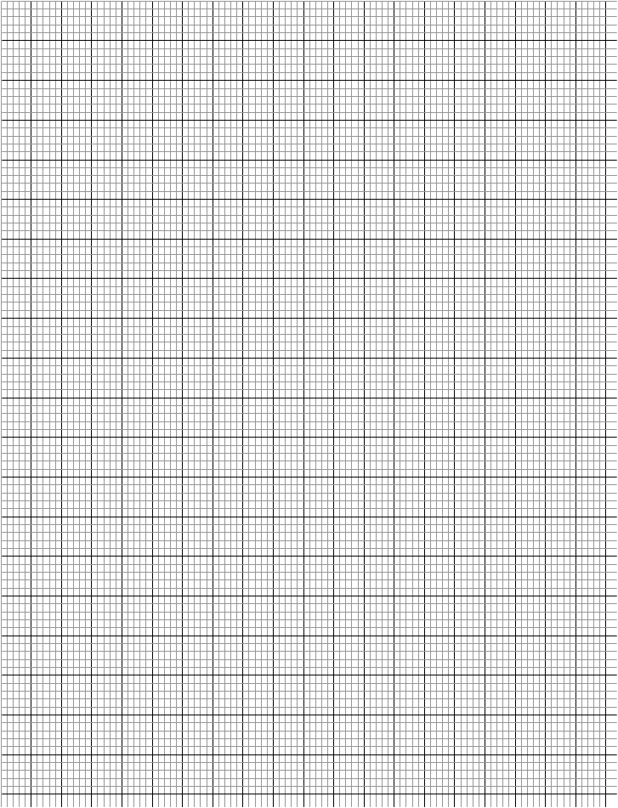
- Calculate the gradient of your graph. (3 marks)

- The relationship between y and x is given by $y= \frac{50}{P}$x + C where P is a constant and C is the distance of the centre of gravity of the rule from the ‘zero’ end. From your graph determine;
- The constant P. (3 marks)

- The position of the centre of gravity of the rule. (2 marks)

- (a) You are provided with the following apparatus:
- Resistance wire fitted on a scale labelled MN
- Switch
- Voltmeter
- Ammeter
- Two dry cells
- Six connecting wires

- Set up the apparatus as shown in the figure below;

V
A
M
N
Crocodile clip
Switch
L

- Remove the crocodile clip to the resistance wire such that MN and close the switch. Record the voltmeter reading.

Y=………………………………………..V (1 mark)

- Attach the crocodile clip to the resistance wire such that L=10cm
- Record the voltmeter and ammeter readings in the table below.
- Repeat the procedure in (iii) and (iv) for L=20cm, 30cm, 50cm, and 80cm

- Complete the table below; (5 marks)

Length L=cm | 10 | 20 | 30 | 50 | 80
Current I (A)
P.d (V)
Y-V
$$\frac{V}{Y-V}$$
R = $\frac{V}{I}$

b) Plot a graph of R (vertical axis) against $\frac{V}{Y-V}$ (5 marks)


c) Determine the slope m of the graph (2marks)

d) The graph is given by the equation $R=\frac{5mv}{y-v}+d$ determine the value of m and d (2 marks)

(b) You are provided with the following set of apparatus
- A metre rule
- A white screen
- A candle
- Lens and lens holder
Procedure
- Set up the apparatus as shown

L₁
L₂
Screen
Lens
Candle

- Starting with L₁=30cm, adjust the position of the candle in order to obtain a sharp image on the screen. Record the value of L₂………………………………………. (1mk)
- Repeat the procedure for L₁=60cm
- Fill and complete for values of L₁/L₂ below. (3 marks)
L₁cm | L₂(cm) | $$\frac{L_{1}}{L_{2}}$$
30
60
- Given the equation
$$F_{1}=\frac{L_{1}}{m+1}$$
When m=magnification determine the value of focal length f, (2 marks)

